Home Page:
- Dear Lab Square logo, embossed with background or borders merged.
- Remove tabs: Explore research and Meet the team.
- Our Vision:
Decoding RNA. Discovering vulnerabilities. Engineering solutions.
- Description under Vision:
At the Disease Engineering and Advanced RNA Biology (DEAR) Lab, based at NUCSER, NITTE (Deemed to be University), Karnataka, we seek to understand how RNA governs disease and harness this knowledge to engineer innovative solutions for cancer and other intractable diseases.
Our research sits at the intersection of RNA biology, cancer biology, mechanobiology, and bioengineering. We investigate the complex regulatory landscape of non-coding RNAs, including long non-coding RNAs (lncRNAs) and microRNAs, as well as their higher-order structures, interactions, and dynamic organization within cells. By deciphering how these RNA networks influence cellular identity, plasticity, and disease progression, we aim to uncover previously unrecognized vulnerabilities in cancer.
A key focus of our work is understanding how the physical microenvironment shapes RNA-mediated regulation of aggressive cancers. Using biomimetic 3D tumoroid models, we investigate how mechanical cues such as matrix stiffness and cellular forces reshape RNA programs and contribute to tumor progression, invasion, and therapy resistance, with a particular focus on glioblastoma.
We further integrate advanced RNA-sensing and bioengineering technologies to move from discovery to application-developing approaches that can detect, interrogate, and ultimately manipulate disease-associated RNA networks.
Our goal is to move from understanding RNA to engineering disease solutions.

- Remove the lab group picture and instead put this:
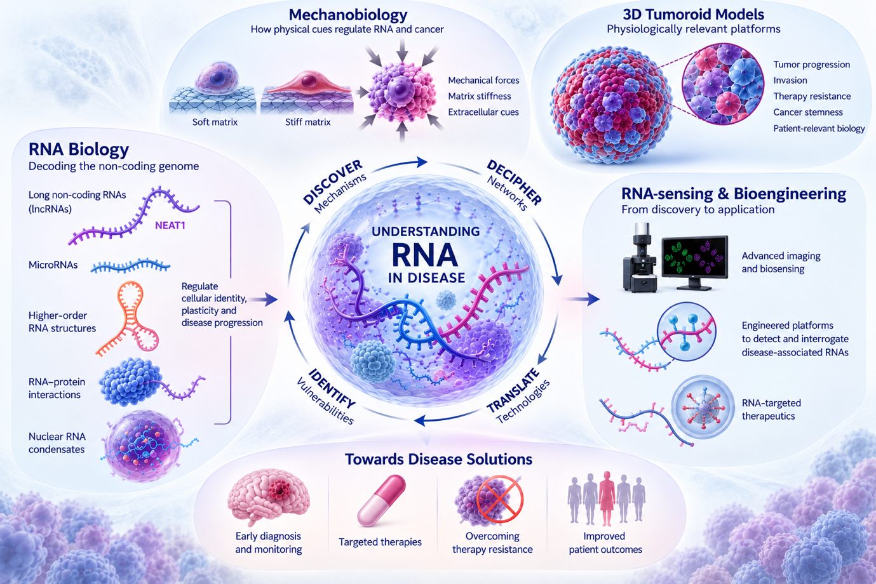
- Remove the Research areas, from the next section as the earlier part of “Learn more about our approach” leads to research page.
- Instead of : “Learn more about our approach” in the earlier section, replace that with “Explore our Research Pillars”
- The banner for metrics, citations papers team members etc., remove for now
- Selected Publications-remove
- Join the lab part – remove
- Last part of the Page, Under MORE: remove Contact.
- In Contact, modify the address: Room no- 200, Level minus 1, NUCSER, Paneer Campus, Deralakatte, Mangalore, Karnataka 575018, India

Research Page: (Sending Later)

Team Page:

- Under Our Team: “Meet the RNA Biologists”
- Remove the word Leadership, only Principal Investigator is fine.
- Similarly Remove the word: Research Group, only Current Members is Fine.
- The multidisciplinary team line is also not required.
- Add all the students’ info- upon click should show their writeup.
- Current Members, Last box can be made dotted: Blank and written “This could be you”- link that below to Join the Team/Group.
- Life at Dear Lab-Remove. Our Research Group and the line below remove.
- About the lab group pic- it will be best if we can move it up- right at the beginning of the page where we mention “Our Team”, then “Meet the RNA biologists” then below that this lab group picture comes- and then Principal investigator… and so on--- This flow is better.
- Remove - Past Members. Only “Alumni” is fine. Keep this space blank for now, the NUSR Students will be transferred here soon.
- Join DEAR Lab:
We are always looking for enthusiastic, curious, and driven researchers to join our team.
Ph.D. positions are available biannually as per NUCSER guidelines. Interested candidates are welcome to contact us for an informal discussion.
We are currently accepting applications for 2- and 6-month internships and postdoctoral positions.
Interested candidates may email arpita.ghosh@nitte.edu.in with a CV and letter of intent.
- About the PI:
Dr. Arpita Ghosh hails from Kolkata, the City of Joy, in eastern India. Her scientific journey has been driven by a deep curiosity about how molecular systems work and how fundamental discoveries can be translated into solutions for human disease.
She began her academic journey with a B.Tech.–M.Tech. dual degree in Biotechnology from KIIT University, Odisha, followed by a Ph.D. in Biological Sciences from CSIR–Institute of Genomics and Integrative Biology (IGIB), New Delhi, where she discovered the fascinating world of RNA biology and its structural and functional possibilities. She subsequently pursued postdoctoral research in the Department of Chemical Engineering at IIT Bombay, first as an Institute Postdoctoral Fellow and later as an ANRF National Postdoctoral Fellow, working at the intersection of RNA biology, cancer, mechanobiology, and disease engineering.
Today, as an independent researcher and PI, she leads the Disease Engineering and Advanced RNA Biology (DEAR) Lab at NUCSER, NITTE, built around a central question:
Can we understand RNA deeply enough to engineer better solutions for cancer?

Her research explores long non-coding RNAs, microRNAs, RNA structures and higher-order RNA organization, and how these regulatory systems respond to the physical tumour microenvironment. Her work integrates RNA biology, mechanobiology, 3D tumour models, advanced sensing technologies, and therapeutic approaches to uncover mechanisms of cancer progression and therapy resistance.

Dr. Ghosh is an awardee of several prestigious national and international recognitions and has presented her research at scientific forums across different parts of the world.

Away from the laboratory, Arpita finds joy in music, dance, visual storytelling, and science communication. She loves telling stories—whether through a scientific figure, a research talk, a camera, or simply sharing the everyday journey of being a scientist. For her, creativity and science are not two separate worlds; both begin with curiosity, imagination, and the courage to ask questions.
And that spirit of curiosity is at the heart of DEAR Lab.

Publications Page:
- Remove the line: Key paper….engineering.
- After Publications : put the list 1, 2,3…..
- Remove: Research output, Key publications, Peer reviewed….therapeutics.
- After the list ends, put the Banner with the Google scholar profile and view completed list part.
- Remove: Metrics and Impact section.
- “Interested in collaborative research”, remove from this section.

Lab News:
- Remove Updates, Recent news and highlights and the explore line under that. Only keep the Lab News Banner and the line below that: Latest Updates and Events from DEAR Lab.
- The Recent News in Chronological Order will be:
- April 2026- The First Publication from DEAR Lab, in Collaboration with IIT Bombay and IISc Bangalore got published in Wiley: Macromolecular Biosciences. Hooray!
- April 2026- BSc Biomedical Science Honours students: Jalisha, Vivechana, Shanelle, Sanjana, Prathiksha and Prerana, each got their NUSR Grants. Kudos to all!!
- April 2026- DEAR Lab got the first Intramural NUFR Grant Awarded from Nitte University. We are set to roll!
- April 2026- DEAR Lab gets its 1st Extramural Grant: Prime Minister Early Career Grant awarded by ANRF for 3 years.
- July 2026- DEAR Lab welcomes the First JRF Student, Ashish Soman Yogesh as Project Associate-1 under the ANRF-PMECRG Project. Welcome Ashish!!
- August 2026- Arpita is invited as a speaker for the National Conference on Quantum Biotechnology at IIT Bombay. She delivers her talk on “From Fixed Footprints to Live Folds: NV-Centre Quantum Sensing of Oxidative Damage and RNA Structural Plasticity in Glioblastoma”.
- DEAR Lab welcomes 1-year Masters Students. Davika and Teertha from MSc Cancer Biology and Siddhanth from Biotechnology. Welcome to DEAR Lab!!
- Remove Archive and Past Newsletters for now.
- Remove: stay connected with DEAR Lab part full.

Gallery:
Photos for Gallery (will be included later)

Contact:
- Location: DEAR Lab (Cancer Bio Lab), 1st Floor, NUCSER, NITTE (Deemed to be University), Paneer Campus, Deralakatte, Mangalore, Karnataka 575018, India
- Remove Phone.
- Remove Web.
- Social Media Links:

- Under Opportunities:----Join the Dear Lab: Redirect to the Teams Page’s “Join DEAR Lab” part.

